WT-Assigmrnt9&10

By:- Anusthan Singh (20051337) cse-9

* Q1 **Write a java program to display "Hello World" Message on Applet screen.**

Code:-

import *java.applet.Applet*;

import *java.awt.Graphics*;

*public* *class* q1 *extends* Applet {

*public* void paint(Graphics g) {

        g.drawString("Hello world!", 50, 25);

    }

}

*/\**

*<applet code="HelloWorld.class" height=300 width=200>*

*</applet>*

*\*/*

Output:-

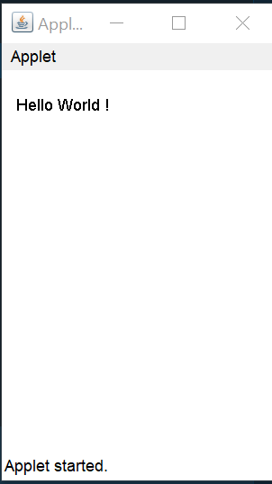

* Q2. **Write a java program to design an applet to display the user information such as Roll No., Name,  
  Branch and Section in separate lines.**

Code:-

import *java.applet.\**;

import *java.awt.Graphics*;

*public* *class* q4 *extends* Applet {

*public* void paint(Graphics g) {

 g.drawString("Anusthan Singh", 150, 150);

 g.drawString("20051337", 150, 200);

 g.drawString("CSE-9", 150, 250);

 }

}

*/\**

*\*  * <applet code="q4.class" height=300 width=200>*

*\*  * </applet>*

*\**

*\*/*

Output:-

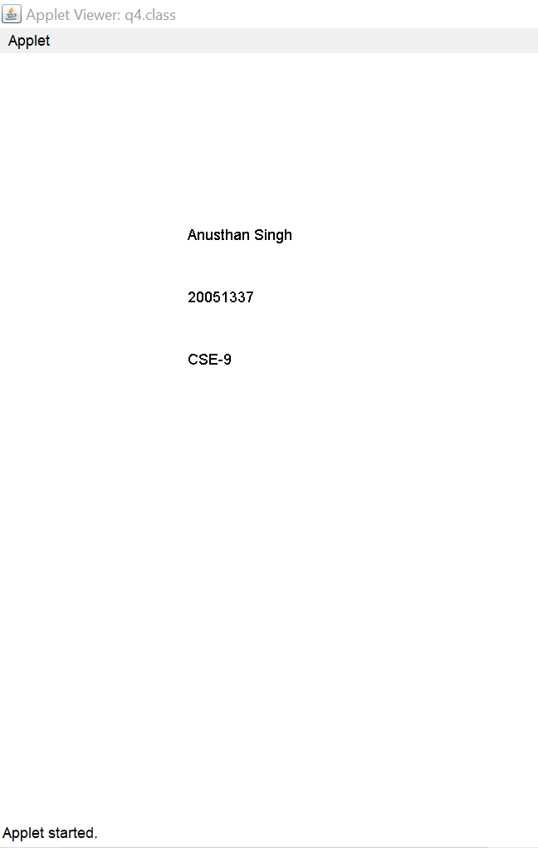

Q3. **Design an applet to display a colored smiley.**

Code:- import *java.awt.\**;

import *java.applet.Applet*;

*public* *class* smiley *extends* Applet

{

*public* void paint(Graphics g)

    {

       g.setColor(Color.cyan);

       g.fillOval(20,20,150,150);

       g.setColor(Color.black);

       g.fillOval(50,60,15,25);

       g.fillOval(120,60,15,25);

       int x[]={95,85,106,95};

       int y[]={85,104,104,85};

       g.drawPolygon(x,y,4);

       g.drawArc(55,95,78,50,0,-180);

       g.drawLine(50,126,60,116);

       g.drawLine(128,115,139,126);

    }

}

*/\**

*<applet code="smiley" height=200 width=200>*

*</applet>*

*\*/*

Output:-

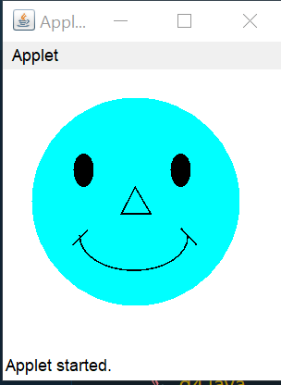

Q4. **Write an applet that places a rectangle, a rounded rectangle, a 3D rectangle and fill rectangle of random sizes and colors inside the applets visible area.**

Code:- import *java.applet.\**;

import *java.awt.\**;

*public* *class* q6 *extends* Applet {

*public* void paint(Graphics g) {

  g.drawRect(10, 150, 50, 100);

  g.drawRoundRect(70, 150, 50, 100, 10, 10);

  g.setColor(Color.orange);

  g.fill3DRect(130, 150, 50, 100, true);

 }

}

*/\**

*\*  * <applet code ="q6.class" width=600 height=600>*

*\*  * </applet>*

*\**

*\*/*

Output:-

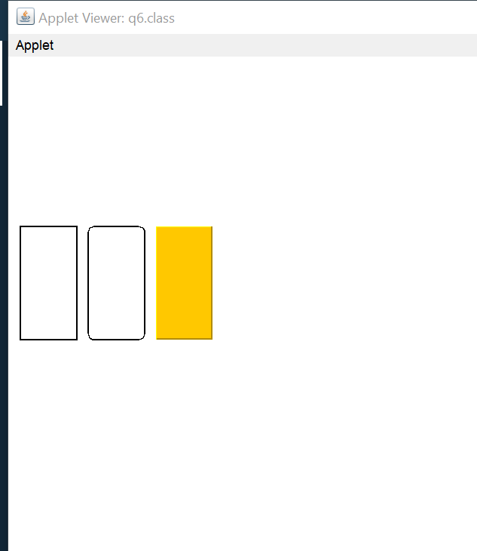

Q5. **Write a program in Java to copy the content of a given file to another user entered file using character stream.**

import *java.io.FileOutputStream*;

import *java.io.FileInputStream*;

*public* *class* q5 {

*public* *static* void main(String[] args) {

  try {

   FileInputStream fin = new FileInputStream(

    "one.txt");

   FileOutputStream fout = new FileOutputStream(

    "two.txt");

   int i = 0;

   while ((i = fin.read()) != -1) {

 fout.write((char) i);

   }

   fin.close();

   fout.close();

  } catch (Exception e) {

 System.out.println(e);

  }

 }

}

Output:-

one.txt

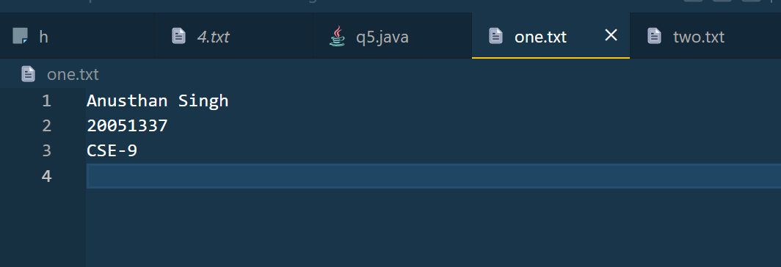

two.txt

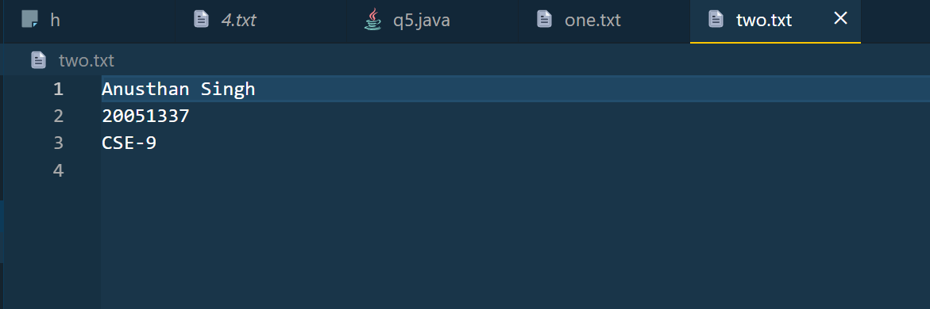

Q6 **Write a java program to capitalize first letter of every word in a file.**

Code:-

import *java.io.FileOutputStream*;

import *java.io.FileInputStream*;

*public* *class* q3 {

*public* *static* void main(String[] args) {

 try {

 FileInputStream fin1 = new FileInputStream("five.txt");

 FileOutputStream fout1 = new FileOutputStream("six.txt");

 int i = 0, flag = 1;

 char ch;

 while ((i = fin1.read()) != -1) {

 ch = (char) i;

 if (flag == 1) {

  ch -= 32;

 flag = 0;

 }

 if (ch == ' ')

  flag++;

 fout1.write(ch);

 }

 System.out.println();

 fin1.close();

 fout1.close();

 } catch (Exception e) {

 System.out.println(e);

 }

 }

}

Output:-

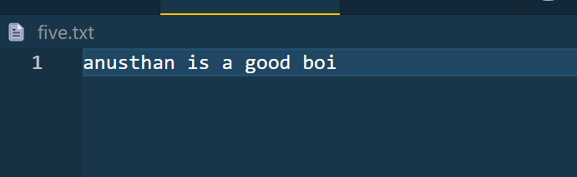

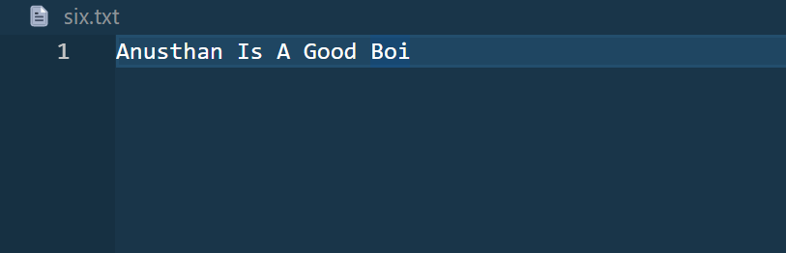

Q7. **Write a java program to compare two binary files, printing the first byte position where they differ.**

import *java.io.FileInputStream*;

*public* *class* lab10q2 {

*public* *static* void main(String[] args) {

  try {

   FileInputStream fin1 = new FileInputStream(

  "3.txt");

   FileInputStream fin2 = new FileInputStream(

   "4.txt");

   int i = 0, j = 0, count = 0;

   while (((i = fin1.read()) != -1) && ((j = fin2.read()) != -1)) {

   if (i != j) {

    System.out.println(count);

    break;

   }

   count++;

   }

   fin1.close();

   fin2.close();

  } catch (Exception e) {

   System.out.println(e);

  }

 }

}

Output:-

3.txt

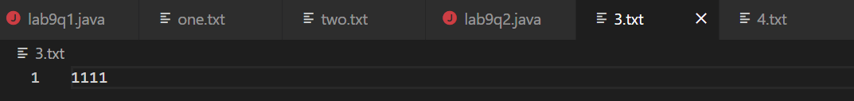

4.txt

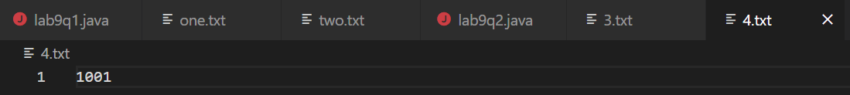

By:- Anusthan Singh(20051337)